1 ) Create user with name Techie and provide sudo access to user. ?
Useradd username
vi /etc/sudoers - to provide access to any user in sudoers

2) Navigate to the home directory.

Cd ~

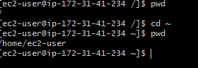

3) Create a new directory.
Mkdir name
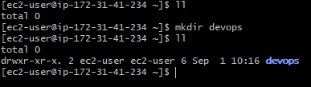
4) List the contents of a directory.
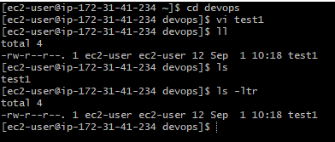
5) Change the current directory.
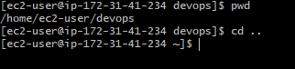
6) Create a new empty file.
touch filename
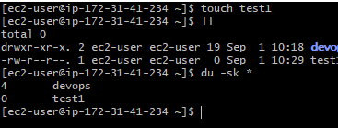
7) View the contents of a file.
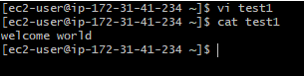
8) Copy a file to another location.
Cp filename destination path
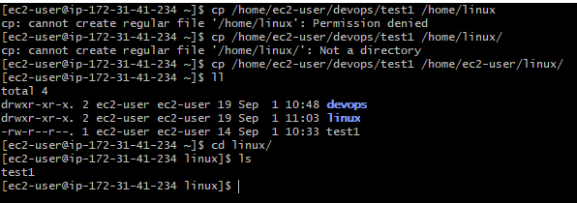
9 ) Move a file to another location.
mv filename destination path
10) Rename a file
mv filename newname
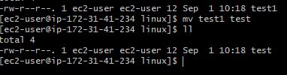
11) Delete a file.
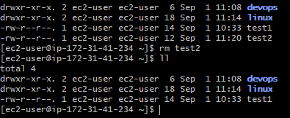
12) Grant or revoke permissions on a file or directory.
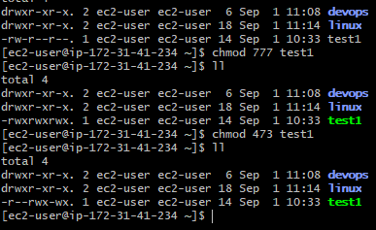

13) View the current date and time.
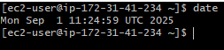
14) Check the system uptime.
Uptime
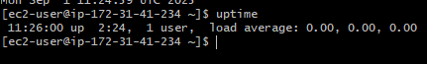
15) View the running processes.
ps -ef
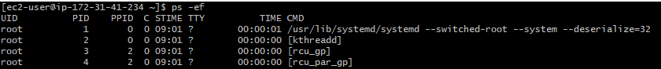
16) Kill a running process.
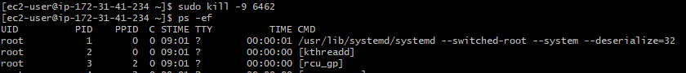
17) Install a package using the package manager (e.g., apt or yum).
Sudo yum install nginx
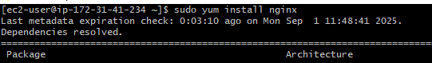

18) Update the system packages.
Sudo yum upgrade –y or sudo yum update -y
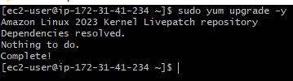

19) Create a symbolic link.
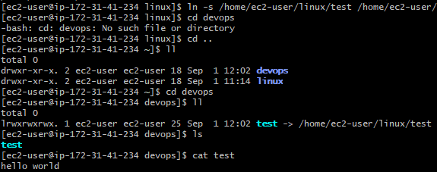
20) Search for files using the find command.
Sudo find / -type f –name “filesname”
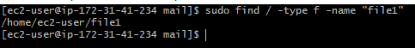
21) Compress and decompress files using tar.
Tar cvf newname.tar filename
Tar xvf newname.tar
22) Monitor system resources with top or htop.
To check system resources – top
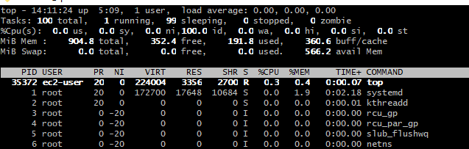
23) Create and manage user groups.
sudo groupadd developers (group name) : create a new group
groups devops(username) : to view user from group
sudo usermod -aG developers (group name) devops (username) : add a user to group
cat /etc/group : to view all groups in the system
grep '^developers:' /etc/group : to check or view particular group

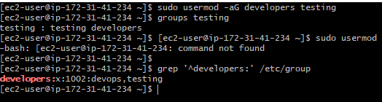
24) Set up SSH password less authentication.

25) Monitor log files using tail or grep.
Tail –f filename
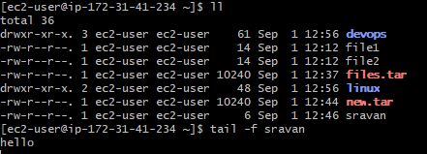
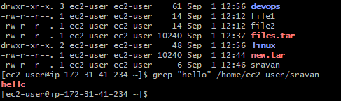
26) Set up a web server (e.g., Apache or Nginx).
Sudo yum update -y
sudo yum install nginx -y
sudo systemctl enable nginx
sudo systemctl start nginx
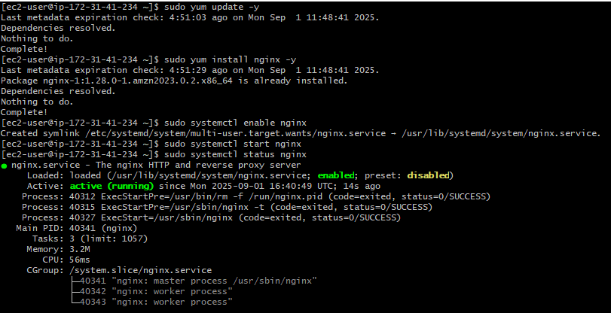

27) Configure and secure a MySQL Database.
Download & Import MySQL GPG Key :
sudo rpm --import https://repo.mysql.com/RPM-GPG-KEY-mysql-2023
Install the MySQL Yum Repo:
sudo dnf install -y https://dev.mysql.com/get/mysql80-community-release-el9-1.noarch.rpm

Install MySQL Server:
sudo dnf install -y mysql-community-server

30) Print specific columns from a delimited file.
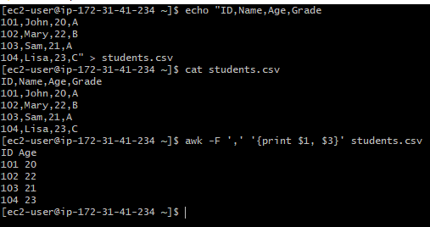

31) Filter and print lines based on a specific pattern or condition.
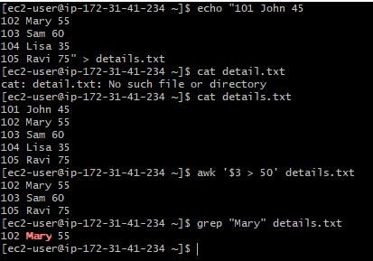
32) Calculate and print the average, sum, or other statistics of a column.

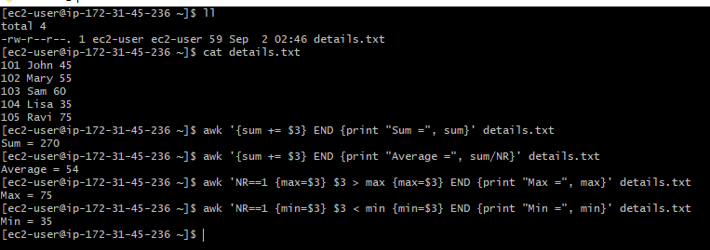
33) Perform string manipulation, such as extracting substrings or changing case.
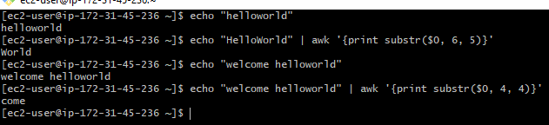
34) Count the occurrences of a specific pattern in a file.
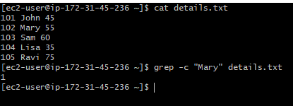
35) Sort lines based on a specific field or column.
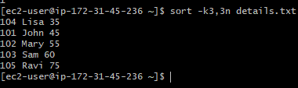

36) Merge multiple files based on a common field or column
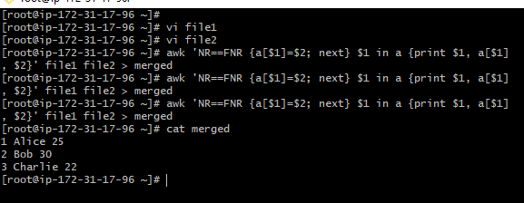
37 Substitute text in a file using search and replace.

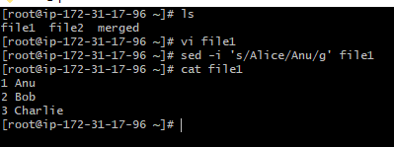
38 Delete specific lines based on a pattern or line number.
Example: file1
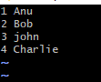

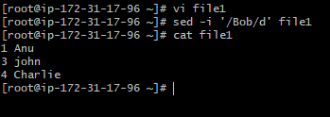
Append or insert text before or after a specific pattern or line.
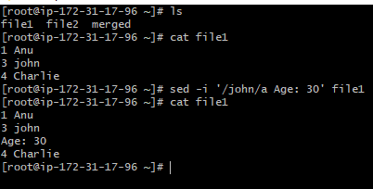
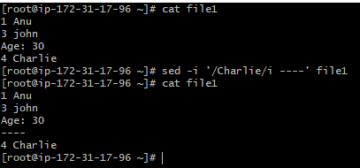
40) Print only specific lines from a file.
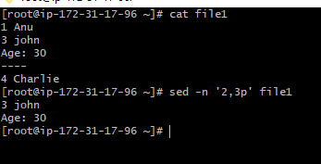

Copy file from linux to windows machine
